**PROJECT MANAGEMENT**

* 1. **Project Planning**
     1. **Project Development Approach and Justification**

For the project development we used iterative model as we all in the learning phase . In Iterative model we can go back to the previous phase if any problems with design or with development encountered . So as justified it is very to use and perfect for this small project development .

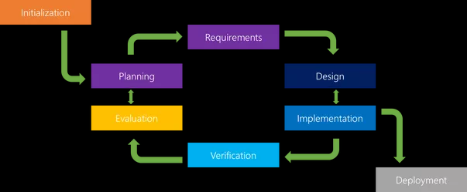

Figure1.**Error! No text of specified style in document.**.1 Iterative Model

* + 1. **Project Effort and Time, Cost Estimation**

As we all in the learning phase of .net framework and C# language we had to decide some decent definition so it takes much time for us to decide the definition . And it takes some time to us to learn C# . At some point we all disagree on some matters so that expands the development . At some points error solving took much more time for evaluation . But all the efforts came to the end on the time. As the project is entirely based on the .net framework and C# it costs only time . No financial cost is applicable in this project . Only need ethernet connections in the network .

* + 1. **Roles and Responsibilities**

As the project requirements we all changes our roles as per the requirements . At some time one took responsibility of design interface where others took coding phase . At some point as per the design requirement one changes his role from coding to deign and the all parts going as well . We all took little little responsibilities of the some coding and design as per requirements .

* 1. **Project Scheduling (Gantt Chart/PERT/Network Chart)**

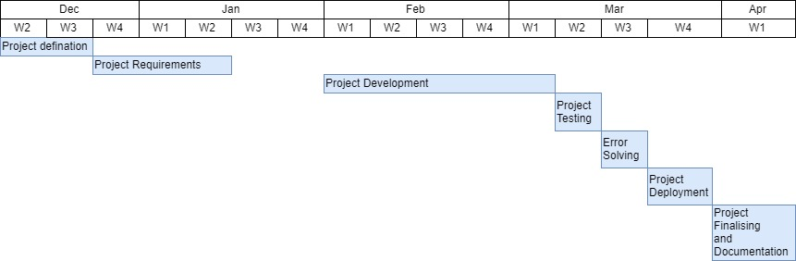

Figure 1**.**.2 Gantt Chart